**Lesson 4 Demo 1**

**Install a Software Wallet**

|  |
| --- |
| **Objective:** To install the Exodus software wallet  **Tools required:** Ubuntu, Web browser  **Prerequisites:** None |

Steps to be followed:

1. Downloading and installing the Exodus software wallet

**Step 1: Downloading and installing the Exodus software wallet**

1. Open the web browser and navigate to <https://www.exodus.io/>
2. Click on the **Download** button to download Exodus software wallet



1. Click the **Exodus Download** button under the **Desktop** section and select the **Download Linux App** option to start the download

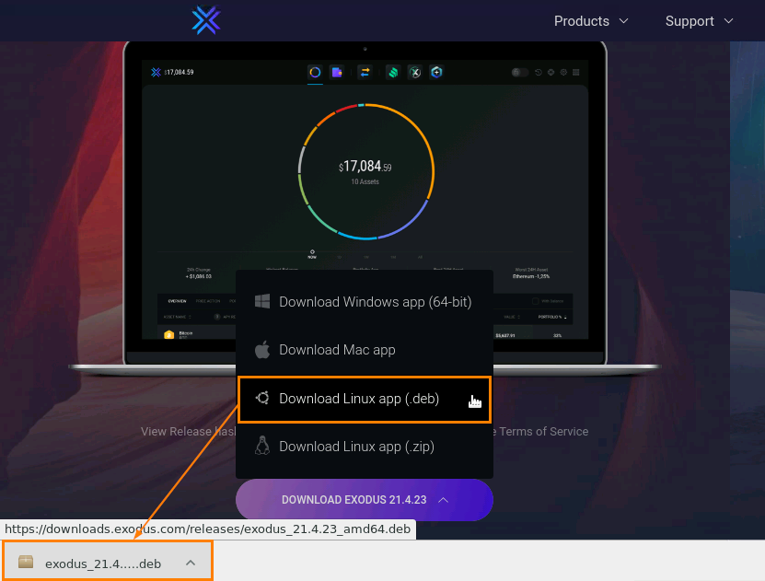

1. Right click on the downloaded file and select **Show in Folder**

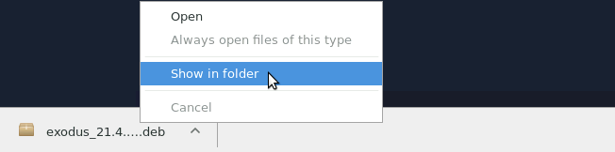

1. Copy the path of the downloaded file

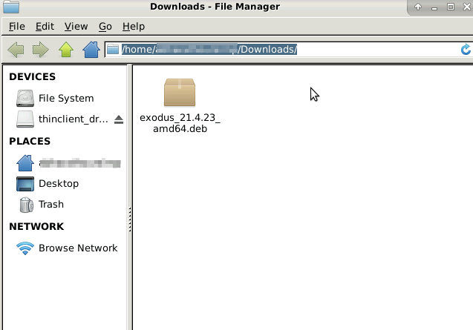

1. Open the Terminal and enter the following command:

*sudo dpkg -i ABSOLUTE_PATH/exodus_21.4.23_amd64.deb*

|  |
| --- |
| **Note:** Replace the ABSOLUTE_PATH with the copied path from step 1.5 |

*sudo apt-get install -f*

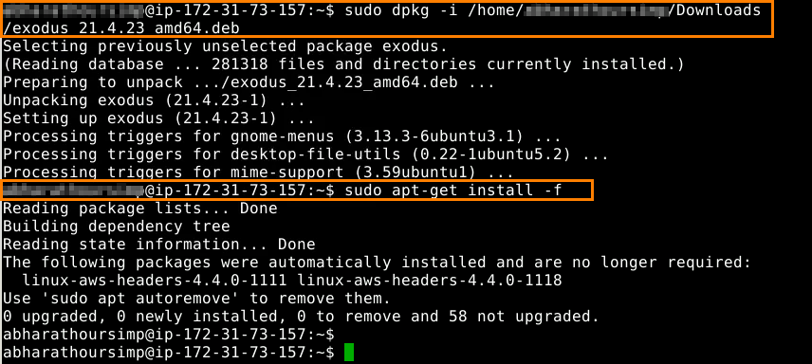

1. Open the **Application Finder** and search for Exodus
2. Select the **Exodus** icon and click **Launch** to open the Exodus wallet

